**# Model Diagnostic**

* It defines Statistically significance of model
* How dependent variable is impacted by certain features
* Which features to choose and leave

Some Evaluation metrics

1. **P-value:**

* It gives probability of target i.e. dependent variable and features i.e. independent variable are not linearly correlated.
* It is indicator is not absolute measure .
* p>0.05: Do not consider as a candidate for linear regression.
* p<0.05: Can consider a candidate for linear regression.

1. **R square:**

* It shows how well a feature explains the variation of label i.e., dependent variable.
* R-square>0.7 is good score for feature we can add
* Works well we check features individually.

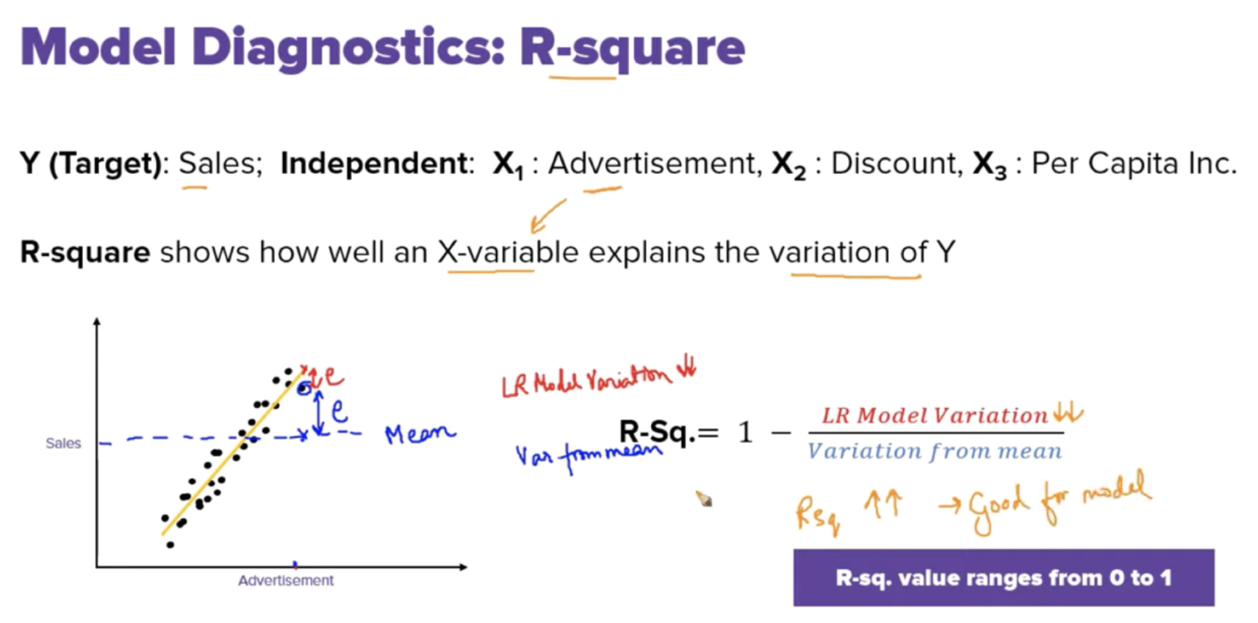

Problems with R square:

* When we combine two or more features R-square value is always greater and then it can lead to overfitting

**Adjusted R square:**

* It penalizes addition of features

**Variation Inflation Factor**

* In Regression we do not want Multi collinearity
* Helps to determine multi collinearity.
* VIF high worst there is multi collinearity VIF>8
* VIF low best there is multi collinearity VIF<8 usually (5-10)

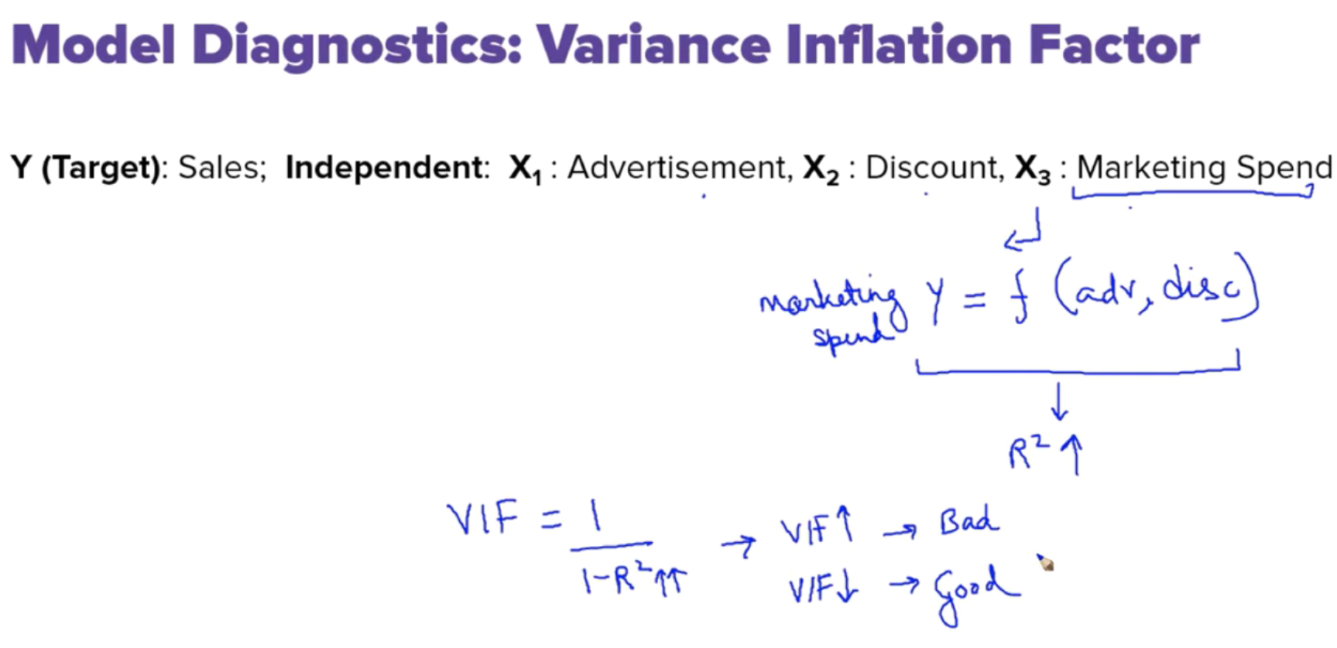

**Multiple Linear Regression**

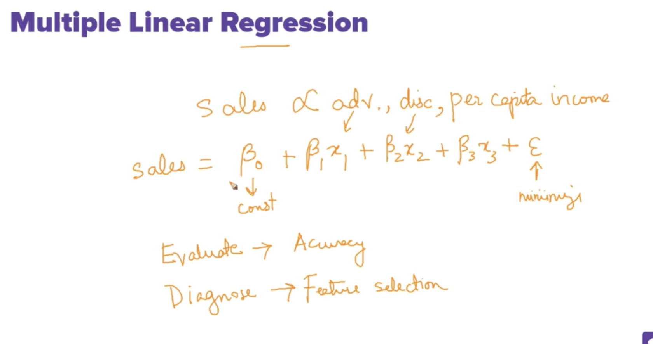

**Assumptions in Linear Regresssion:**

* **Linear relation**
* **Little or no Multi colinearity**
* **Mean of errors should be zero and should follow Normal Distribution**
* **HomoScedacity:There should be no pattern observed between errors in x variables**

